Problem Statement Definition

Based on the brainstorming outcomes and empathy mapping insights, the core problem was clearly defined.
3.1 Existing System Limitations
- Reactive fault detection
- Limited sensor coverage
- No future temperature estimation
- High maintenance and downtime costs
- Inefficient preventive maintenance strategies
3.2 Defined Problem Statement
“To design and implement a machine learning-based system capable of accurately predicting motor temperature using operational and environmental parameters, enabling early fault detection and predictive maintenance to reduce motor failures, downtime, and maintenance costs.”
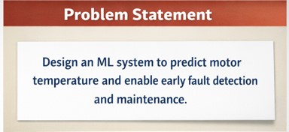
3.3 Objectives Derived from the Problem Statement
- Predict motor temperature in advance
- Use historical and real-time sensor data
- Improve reliability and safety of motor operations
- Enable predictive maintenance strategies
- Reduce operational and maintenance costs

Conclusion of Ideation Phase
The ideation phase successfully transformed a general concern about motor overheating into a clearly defined, user-focused problem statement. By systematically conducting brainstorming and empathy mapping, the project established a strong foundation for the subsequent phases such as system design, model selection, implementation, and evaluation.

